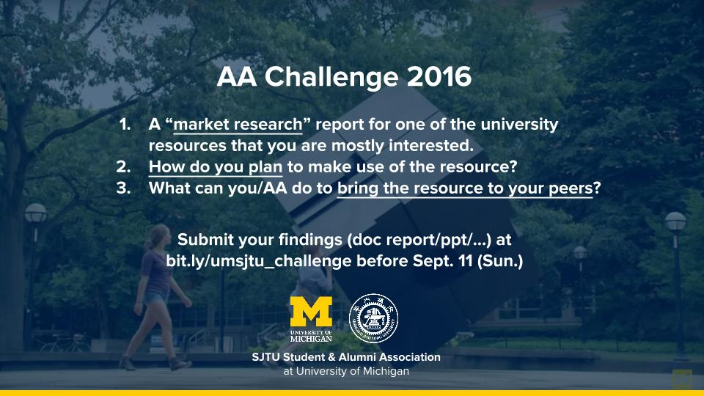

Market Research

Target:

UM Student Employment Office

Background:

Among the Chinese students, especially the new-coming students, job seeking becomes one of most concerned issues. The UM student employment office offers a rich list of job among campus for undergrads and graduate student, helping them get involved in available work-study job positions.

Market Information:

The [official website](https://studentemployment.umich.edu/Cmx_Content.aspx?cpId=27) of Student Employment provides students with multiple work-study jobs to U-M grads and undergrads. The jobs include community service jobs, housing jobs, library jobs, non-community jobs and so on.

How to make use of it:

Job information and even the research recruitment information are posted on the [webpage](https://studentemployment.umich.edu/JobX_FindAJob.aspx?t=qs&qs=20). If I want to seek some undergraduate research opportunities, it’s a good alternative way. Or if I would like to choose some work-study position, it must be the better information source for me.

What I/AA can do for the resource:

As individual, I can use this resource to find the job I am personally interested in. I find that the available positions also include research assistant and program assistant, which will benefit my future study and research, providing us with more opportunities in seeking undergraduate research. As for AA, I think we can cooperate with the student employment office. The demand of student employment is to find the qualified student in the campus job position, while our demand is to help our members get involved into campus life and integrate information resource for members. Therefore, we may build a platform or an access through SEO with our organization to help our members find what they truly want and get it. Or even better, we can divide the information according to the major and send it via email to the correspond students in AA for consideration.